**Request for Information (RFI) Response for  
Tracking No. ESEP190025AP  
Office of Migrant Education (OME) / High School Equivalency   
Program (HEP) and College Assistance Migrant Program (CAMP)   
Technical Assistance Support**

Submitted on: 07-October-2022

Submitted to—  
US. Department of Education  
Office of Migrant Education (OME)

Submitted by—

**HunaTek Professional Services**   
13900 Lincoln Park Drive, Suite 350  
Herndon, VA 20171

POC: Timothy J. Fitzgerald, Chief Operating Officer   
[tim.fitzgerald@hunatek.com](mailto:tim.Fitzgerald@Hunatek.com) | tel 571-464-5198 | <https://hunatek.com>

**Contents**

Company Overview 1

Capability to Provide Technical Assistance to HEP and CAMP grantees 3

History of Successes 7

|  |  |
| --- | --- |
| **Company Name:** | HunaTek Professional Services (HunaTek) |
| **Address:** | 13900 Lincoln Park Drive, Suite 350 Herndon, VA 20171 |
| **Phone:** | 571-464-5198 |
| **Website:** | https://hunatek.com |
| **Unique Entity ID:** | VLLKTRK4ANF3 |
| **Cage Code:** | 73D83 |
| **Business Classification / Size:** | 8(a) small business |
| **Point of Contact:** | Timothy J. Fitzgerald, Chief Operating Officer [tim.fitzgerald@hunatek.com](mailto:tim.Fitzgerald@Hunatek.com) |

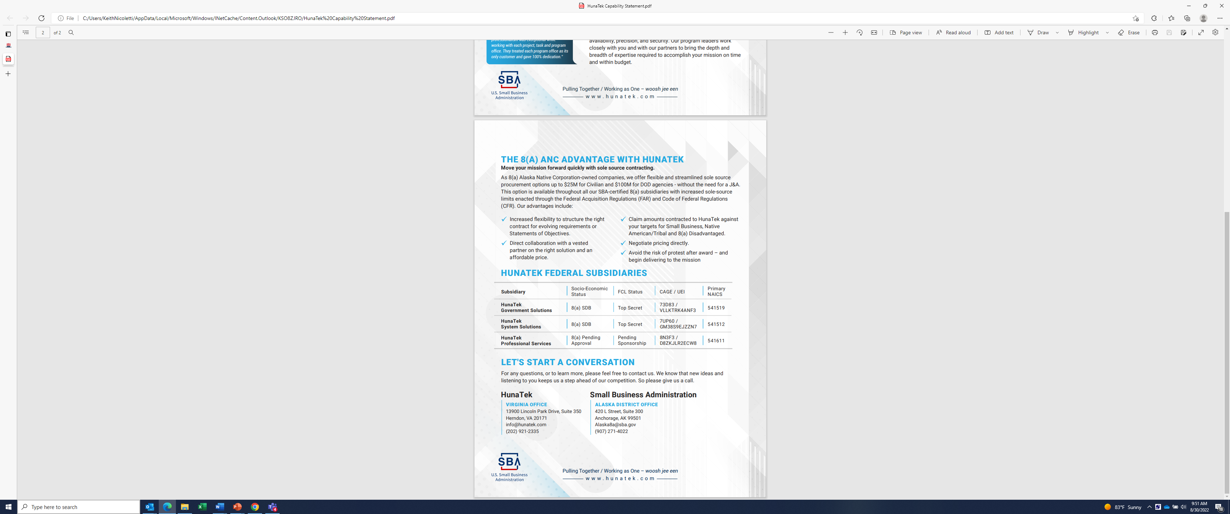

# Company Overview

HunaTek Professional Services (HunaTek) is one component of a portfolio of 8(a) Alaska Native Corporation (ANC)-owned Small Disadvantaged Business entities held and governed by HunaTek Holding, LLC. We appreciate this opportunity to respond to the Department of Education’s HEP/CAMP Technical Assistance Support market research requirement. HunaTek has its principle place of business at 13900 Lincoln Park Drive, Suite 350, Herndon, VA 20171.

HunaTek holds the following contract vehicles: 8(a) STARS III, GSA Multiple Award Scheduled (MAS, formerly Schedule 70) and FAA eFAST. HunaTek’s registration in the System for Award Management (SAM) is current and complete.

HunaTek is an excellent choice to lead this effort because of our outstanding track record. HunaTek’s ability to meet government requirements is predicated on an approach refined over years of work at federal agencies. As previously described, the HunaTek Project Management Toolkit is a set of methodologies and processes use by our experienced staff to achieve mission objectives. It is based on a these factors:

* + Professional lessons learned, enabling the authors of this response (subject matter experts in various relevant areas) to make a basic order of magnitude estimate utilizing industry-standard guidelines moderated by our real-world experiences;
  + Expert judgment — from hands-on experience and understanding of the project requirements, based on our understanding of what the U.S. Department of State requires to be delivered; and
  + Parametric model estimating, a scientific method that auto-calculates estimates using detailed data from previous activities.

Eliminate performance risk with HunaTek. We achieve 100% performance success, thanks to the HunaTek Project Management Toolkit. Our regularly scheduled reporting methods provide near-real time visibility into our performance, enabling us to identify any key performance indicators (KPI) that are trending towards the threshold of a negative variance before it impacts program delivery. Thus, we are able to provide complete transparency to the OME/HEP and recommend process improvements that deliver measurable increases in performance and customer satisfaction in supporting event management and attendee support services requirements.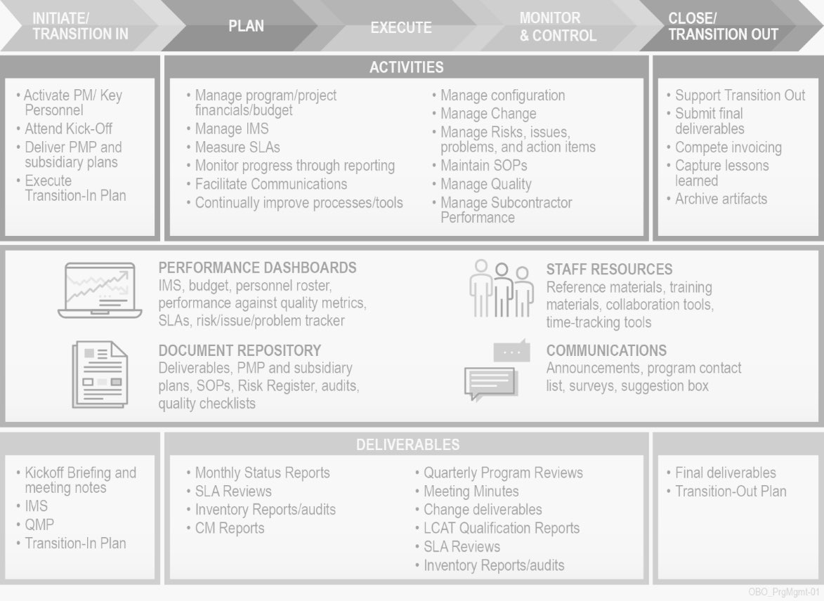

The HunaTek Project Management Toolkit framework is based on best practices such as Project Management Body of Knowledge (PMBOK), ISO 9001:2015, CMMI L3, and ITIL v3. HunaTek provides peer-reviewed process improvement to ensure new procedures completely align with Department of Education (DoED) and other federal recommended standards. We provide a professional team to support SMEs and others in the served community with “white glove” service: updating the customer in a timely manner; making every effort to follow up with the customer within a few hours of receiving the request or other engagement, to let them know you are working on their request; and, providing desk side service if practical.

# Capability to Provide Technical Assistance to HEP and CAMP grantees

HunaTek’s performance approach to successfully employ our substantial task-related capabilities with innovative processes and tools. We undertake to proactively manage our services and the workforce that provide them, in alignment with Office of Migrant Education High School Equivalency Program (HEP) and College Assistance Migrant Program (CAMP) needs, as articulated in the draft Performance Work Statement (PWS).

The HunaTek approach — how we implement out methodology — is summarized in five steps: Our PM and support staff work with the event owner to understand the purpose and refine the agenda. This creates the bounds for the needed assets, technology, venue specifics, and other logistical details. We then identify the participant (audience), set a schedule for the meeting and Distribute the Agenda. HunaTek then executes against our blueprint to support the meeting. Post-meeting, we assign action items to improve what we implemented as AV/IT and other support. We then create, distribute and archive the minutes, and, finally, analyze activity and implement changes. In support of the OME/HEP our staff will maintain the events calendar and all documentation relative to booking events. This includes call logs, email communication with clients and the government coordination team, event folders, event reports and post event data.

HunaTek’s program management team uses common tools (such as Microsoft Project) and processes (such as Transition, Estimating, Risk Management, Communication, and Reporting Processes) to enable a mature Project Management Institute (PMI)-based Program Management Process that is structured, documented, and repeatable. Our PMs apply program management disciplines to plan, schedule, organize, and deploy resources; control task execution; monitor and report on progress; and manage and resolve risks and issues. Our mature accounting system and procedures ensure timely and proper billing and accurate timekeeping. We abide by all applicable Federal laws, regulations, policies, and procedures as they apply to the Department of Education as a whole or deeper within its organizational structure such as the Office of Elementary & Secondary Education as well as its Office of Migrant Education.

The guiding document for governance of HunaTek Programs is the Program Management Plan (PMP). The PMP documents the various management areas methodology, tasks, schedule, allocated resources, and interrelationships with other plans and Standard Operating Procedures (SOPs). It provides details on the required functional units, operational tasks, and deliverable, milestone, and review activities.

For example, for a recent event, we quickly sourced from our pool of approved vendors the video and still photography required, reliving in the same day production and editing of a final multimedia presentation. We will provide support to the COR in defining clients’ requirements and matching the appropriate OME/HEP tools to meet these requirements. When a meeting, exercise, demonstration, or experiment is scheduled, our staff coordinates with our customer and the sponsoring organization to write support plans that are part of the overall requirement. These plans include the units supported and how systems and applications will be used in the event, as well as cost, schedule and performance factors. During the meeting, experiment, exercise, or demonstration our team also provides daily updates/reports identifying potential risks and uncertainties, as well as their mitigations.

***Project Management*** (Tasks 1.x) — Our agile project management methodology, the HunaTek Project Management Toolkit, is available to HunaTek project managers to help address how HunaTek will work with the government’s designated technical representative to monitor the status and progress of work, make adjustments in accordance with established priorities, and request guidance from the contracting officer on major issues that may arise. We will also estimate and report on expected milestones for the completion of tasks and maintain records of work accomplishments according to the deliverable schedules — using our online Virtual Program Management Office (vPMO) web-based portal.

A cornerstone of the HunaTek Project Management Toolkit is the Work Breakdown Structure (WBS), which establishes the framework for: defining the work to be accomplished; construction of an overall plan; and, summarizing the cost and schedule status of a project for progressively higher levels of management. HunaTek provides another advantage over our competition, in the manner in which we relate detailed tasks to successively higher order objectives. We focus on the deliverable end items and their components. The lowest levels are “work packages” which consists of a set of activities related to cost purposes, for ease of audit and budget management.

HunaTek in-house training supports the informal techniques within our Project Management Toolkit. One example is the automated “Tickler File,” often maintained by the project manager in the vPMO as a checklist. The items are filed by date of action, and may note “receive a report, prepare a report, or accomplish an objective.” Another technique is knowledge passed on via on-the-job-training, or woven into our on-boarding training, to aid project managers in gaining higher levels of skill.

Another key differentiator for HunaTek is our early notification SOP. Identifying and notifying the respective stakeholder of potential problems and proposed mitigations in day-to-day support for the Government is a critical function with accountability shared across our entire contract team. Early notification of potential problems is addressed and communicated as part of our risk management process and QC process within our PMP. We integrate QC into all our work products and deliverables, and as a result, potential problems are identified early. If we see errors or problems, we catch them early with our continuous QC reviews. We mitigate risk by implementing a QC process that ensures multiple reviews prior to final delivery of a work product.

They will assume the overarching role of Risk Coordinator to validate, review, and ensure all team personnel identify and provide early notification of potential problems. Security is the other aspect of ensuring execution of such a project that brings to tether so many individuals — physical security as well as information security. HunaTek will ensure that information generated under the work for this contract will not be disseminated to any group, organization or individual other than those authorized under work assignments. To achieve this, we implement an approach based on Quality Assurance (QA) and Quality Control (QC) as two independent but interrelated functions. Our QA/QC starts with a plan focused on two primary functions: (1) the assessment of the quality of outputs (accuracy and precision) measured with KPIs, and, (2) the activities that maintain or improve service delivery quality. Without slowing the flow of work, we have established quality control checks and procedures to review valid samples of work at critical stages in the workflow to determine the accuracy of our work before it proceeds to the next stage.

***Meeting Planning and Support (Tasks 2.x) —*** Logistics support will also include our team formulating draft analyses, presentations, notes, assessments and other material on various technical topics, as required, for use by the OME/HEP. As part of our day-to-day operations, we will conduct end of day checks of the safe log to assure that GSA-approved safes are physically secured. We will author analyses, presentations, notes, assessments, and other material on various technical topics, as required, for use by the OME/HEP. We ensure deliverables in PDF format are Section 508 compliant, as well as any materials intended for publishing on the World Wide Web. We provide logistic personnel to support the government operations, procurement and shipment of program material. HunaTek has provided research and technical documentation of equipment needed for support programs for various Navy operations, and we understand how to assist in the preparation of the material requirements of Navy operations.

Based on our extensive experience, HunaTek is able to provide superior inventory support for contract requirements and material tracking. Because of our expertise with asset management, we will maintain accurate inventory on all AV/VTC systems including spare parts. Our team will scan and electronically file documents as required, providing quality control for layout or technical drawings, security sign-off layout drawings, signed registration lists, letters of appreciation, awards, and facility and safe end-of-day check-out logs.

HunaTek has provided relevant functional event support in the planning, coordinating and executing meetings, exercises, and demonstrations. Our methodology is based on an event management blueprint. The blueprint is a combination of all things that make up our implementation of OME/HEP’s event management processes and definitions. These items will include a set of checklists of the pre-event (planning) requirements and preparation, asset and logistical management, customer support during the event life cycle, and associated operational processes. Our blueprint is the detail behind this process, the “how” behind the methodology. Our value-add is the consistency and quality we deliver by institutionalizing this framework — a framework that can be improved continuously, while our blueprint ensures every event is planned and executed efficiently. HunaTek currently supports event planning and execution for other customers. Our team is experienced with event management for activities hosted on a Government site as well as offsite events at a one of our Contractor facilities. We understand the provision of support for events and meeting planning, addressing attendee support with a significant team available via our surge/bench support human resources processes. Our event planning support regularly includes multiple rooms with technicians and event personnel present for the entirety of the event to support the government’s administrative and technical requirements.

|  |
| --- |
| **HunaTek – Best Value Support** |
| * Quality in-place personnel who are experienced; they are available to be activated on contract award. * More than a decade proven track record serving federal agencies. * Reach back technical support capability and corporate resources to ensure exceptional execution, no matter what “curve balls” might come our way. * Robust infrastructure in the Washington DC area; capability and experience to support meetings nationally. * Realistic and competitive pricing ensures skilled personnel throughout the life of the task. |

***Logistics*** (Tasks 4.x) — HunaTek provides administrative support, addressing the planning for execution of events. We coordinate meeting logistics, customer planning, and “dry run” sessions. Our support team creates required documentation for data calls, explanations, briefs and charts, PowerPoint presentations, and more, as needed. HunaTek corporate reach back means we have the right personnel for research, data retrieval/filtering/compilation and analysis as required. Administrative support is vitally important to the OME/HEP because SMEs and others will be the center point of events. Security most be maintained, and the frictionless execution of meetings (ensured by dry runs) will boost the effectiveness of event outcomes. HunaTek will provide support with our team of experienced technical personnel, meeting the administrative and technical requirements, system types, and other needs of OME/HEP customers. We will attend OME/HEP team/staff meetings, customer planning and dry run meetings, conduct tours of the facility as required, and provide coordination to clients for reserving parking, installation access, and other logistical needs for their event attendees, presenters, and special guests.

Because continuous improvement is a cornerstone of the HunaTek QCP, at the completion of each event, we will prepare a critique sheet for the COR’s review, with lessons learned, a count of onsite and offsite number of attendees, SME attendees, and notes on event operation, security, and all feedback from the event clients. Through our configuration and asset management system we will track and obtain quotes for maintenance and service contracts for network hardware/software, AV equipment, filtration units and other items as required. Our facilities specialists will produce technical documents such as design drawings and performance specifications, obtain quotes from venders, manufacturers and approved sources and compile quote information in spreadsheets to use in the procurement process.

HunaTek is able to deliver support for fully integrated communication systems including timing systems, A/V and VTC systems. Based on nearly two decades of experience, we can integrate and deliver any software and hardware assets into the existing A/V and VTC operational network without causing network disruptions. We provide end-to-end event and meeting management and IT enterprise network services, and we understand the processes, technology, and Federal/DOD regulations that drive our customers’ needs.

The provision of support for events and meeting planning is a vital component of this procurement — providing the right information ahead of time to logistics support, supporting “think ahead” resource management, and providing potential participants read-aheads and agenda all contribute to greater success in knowledge transfer. This is important because we can handle multiple rooms with technicians and event personnel present for the entirety of the event in order to support the government’s administrative needs. As we have when hosting technical briefings, we provide the manual labor for room set-up, job out the video and still photography with rush production and delivery and assist participants and remote attendees with ensuring connectivity and A/V and VTC functionality. HunaTek has almost two decades of personalized support addressing technical issues, both for events/meetings and for day-to-day help desk.

***Subject Matter Expert Support*** (Tasks 3, 4) — HunaTek has extensive experience establishing and maintaining productive working relationships with SMEs. To plan, execute, monitor, and assess this effort, we would put into place the tried-and-true project management assets that HunaTek has used for the past few years to ensure on-time and on-budget task execution. We understand that achieving OME/HEP’s objectives and vision requires collaboration with trusted industry partners that encompass proven skills, knowledge, and ability. Supporting SMEs is a process that requires careful planning and attention to detail. In shaping deliverables in collaboration with SMEs, we actively engage in change management,  to steer passionate experts towards communication solutions that serve audience best.

# History of Successes

HunaTek is a mature company with support functions that enable consistent performance, accountability, and efficiency across the portfolio of projects performed by the company. Our corporate infrastructure enables our program managers, engineers, analysts and other experts to focus on the objectives of the client mission. Working with HunaTek reduces risk to the government because we ensure contract compliance and increased stakeholder satisfaction. We ensure quality service delivery because HunaTek back-office support includes:

* + HunaTek’s Accounting and Finance office maintains accounting and finance policy, and implements controls that enable corporate and project-level budgeting, planning, and financial reporting. Our accounting system is DCAA approved.
  + HunaTek’s Human Resources and Recruiting team manages internal and external staffing requirements in support of all our projects, providing the ability to attract, hire, train, and retain a high-quality workforce. We offer a competitive compensation package, incentivizing employees to grow with the company.
  + HunaTek’s Contracts team administers contracts and subcontracts, and is responsible for procuring materials and services from qualified suppliers and subcontractors.

***Contractor Performance Assessment Report (CPAR) — period ending March 8, 2022***

|  |  |  |
| --- | --- | --- |
| Evaluation Areas | Past Rating | Rating |
| Quality: | N/A | Very Good |
| Schedule: | N/A | Satisfactory |
| Cost Control: | N/A | Very Good |
| Management: | N/A | Very Good |
| Small Business Subcontracting | N/A | N/A |
| Regulatory Compliance | N/A | Satisfactory |

***Transition Successes*** — HunaTek understands the complexities of transitioning mission critical contracts. Our strategy and focus during all program transitions centers on the following:

* A risk-centric system focusing on stabilizing a program during its initial transition while minimizing operational impact and business processes captured.
* Incumbent capture of 80% or more while bringing in new talent for the remaining 20%.
* Minimizes risk of losing domain knowledge at the critical start of contract, while allowing for the opportunity of new ideas and innovation from new talent.

Our results below highlight the successes we’ve enjoyed with our government partner community:

|  |  |  |  |
| --- | --- | --- | --- |
| **Program** | **Transition Days** | **Incumbent Capture %** | **FTE’s** |
| Air Force Special Operations Command (AFSOC) Processing, Exploitation and Dissemination (PED) | 0 | 100% | 14 |
| United States Marine Corps End to End (E2E) Support | 1 Day | 100% | 18 |
| U.S. Army Office of the Judge Advocate General IT Support (OTJAG) | 1 Day | 100% | 33 |
| Department of State Network Operations Branch IT Services (NOMBIT) | 14 Day | 82% | 17 |

As part of transition, we implement a Pre-Award Planning cycle. HunaTek initiates our project staffing activities as early as practical within the contract process to fill key positions, to ensure we exceed customer expectations. Consequently, transition planning and execution is a critical aspect to our process and will start even before the required on-site transition plan meeting. Our goal on day one is to address all the government’s requirements, expanding our capabilities as quickly as possible to address any disconnects. To accomplish this, we work collaboratively with the government, and any existing incumbent. An essential priority is gaining a full understanding of our customer’s current and desired operational needs, mission requirements, and organizational vision. In addition, our transition team captures and analyzes ongoing projects and initiatives, processes, systems and tools in use, as well as organizational culture. Our team also coordinates with any existing incumbents for a transfer of knowledge, as well gaining any additional staffing insights. Our planning purpose is a smooth handoff of responsibilities to ensure no impact to our customers.

|  |  |
| --- | --- |
| **Professional Support Services** | |
| **Contract No.:** | 19AQMM20D0035 |
| **Contract Name:** | Bureau of Counterterrorism Staff Support |
| **Prime or Sub:** | Prime |
| **Contract Officer:** | Kelly Wagner, Branch Chief/Sr. Contracting Officer; [WagnerKM2@state.gov](mailto:WagnerKM2@state.gov) , 202-531-8157 |
| **Contract Specialist:** | Donald Bromell, SME, [BromellD@state.gov](mailto:BromellD@state.gov), 703-875-6112 |
| **COR/COTR:** | Ayanna Gibson, Management Analyst, [GibsonAS2@state.gov](mailto:GibsonAS2@state.gov), 202-634-4605 |
| **Contract Type:** | IDIQ |
| **Contract Value:** | $22M |
| **Period of Performance:** | 3/26/2020 – 3/25/2025 |
| **Contract Description** |  |

Under this contract, HunaTek provides staff augmentation support to the Bureau of Counterterrorism (CT) in accordance with the services defined in specific Statements of Work for each individual task order. The contract has an overall period of performance of 3/26/2020 – 3/25/2025, which includes a base year with four (1) year options. HunaTek is currently providing services under option year 2, which has a period of performance of March 26, 2022 – March 25, 2023.

|  |  |  |  |
| --- | --- | --- | --- |
| **Network Operations Management Branch IT Services** | | | |
| **Agency** | Department of State / Bureau of Overseas Building Operations | | |
| **Title** | Network Operations Management Branch IT Services (NOMBIT) | | |
| **Contract Number** | 19AQMM21D0119 | **Task Order Number** | 19AQMM21F3450 |
| **Contract Type** | T&M | **Dollar Value** | $24,476,936.96 |
| **Award Date** | 9/9/21 | **Period of Performance** | 9/22/2021 - 9/21/2026 |
| **Location(s)** | Arlington, VA | | |
| **Contracting POC** | Patrick T. Dermidoff, Contracting Officer  A/OPE/AQM/FDC/MAJ  1701 N. Ft. Myer Drive, Arlington, VA 22209 (SA-6)  Office: (703) 516-1810  Cell: (202) 531-2669  Email: dermidoffpt@state.gov | | |
| **Technical POC** | Danilo Stapula  - Chief Information Officer, US. Department of State  Bureau of Overseas Buildings Operations  M 571 438 5302 | StapulaDE@state.gov | | |

Under this contract, HunaTek provides staff augmentation support to the Directorate of Cyber and Technology Security (CTS), Bureau of Diplomatic Security (DS). The contract has an overall period of performance of 9/30/2021 - 9/29/2026, which includes a base year with four (1) year options. HunaTek is currently providing services under the base year, which has a period of performance of September 30, 2021 through September 29, 2022.